Seamless Data Flow: EFS to S3 Sync in a Custom VPC

Department: Cloud Infrastructure
Project Type: L1 Project – Centralized File Sharing and Backup System
Submitted By: JAGAJIT. B
Submission Date: 06/03/2026
TABLE OF CONTENTS:
- Introduction

- Objectives

- AWS Services Used

- Architecture Diagram

- Implementation Details

- Challenges Faced

- Lessons Learned

- Conclusion

.

Introduction:
This project demonstrates the design and implementation of a centralized file sharing and backup system using Amazon Web Services. Two EC2 instances hosted inside a custom VPC share a common Amazon EFS file system. Any file created or modified in the shared directory is automatically synchronized to an Amazon S3 bucket in near real-time using I notify monitoring and AWS CLI.
The solution follows least-privilege IAM principles and ensures secure, scalable, and automated backup of shared data.
Objectives:
The primary objective of this project is to design and implement a secure, scalable, and automated centralized file sharing and backup system using core services from Amazon Web Services.

AWS Services Used:
- Amazon Web Services (AWS) – Cloud platform hosting the infrastructure.
- Amazon VPC – To create isolated network environment.
- Amazon EC2 – To launch virtual servers.
- Amazon EFS – Shared file storage across instances.
- Amazon S3 – To store backup copies of files.
- AWS IAM – To control secure access permissions.

Architecture Diagram:
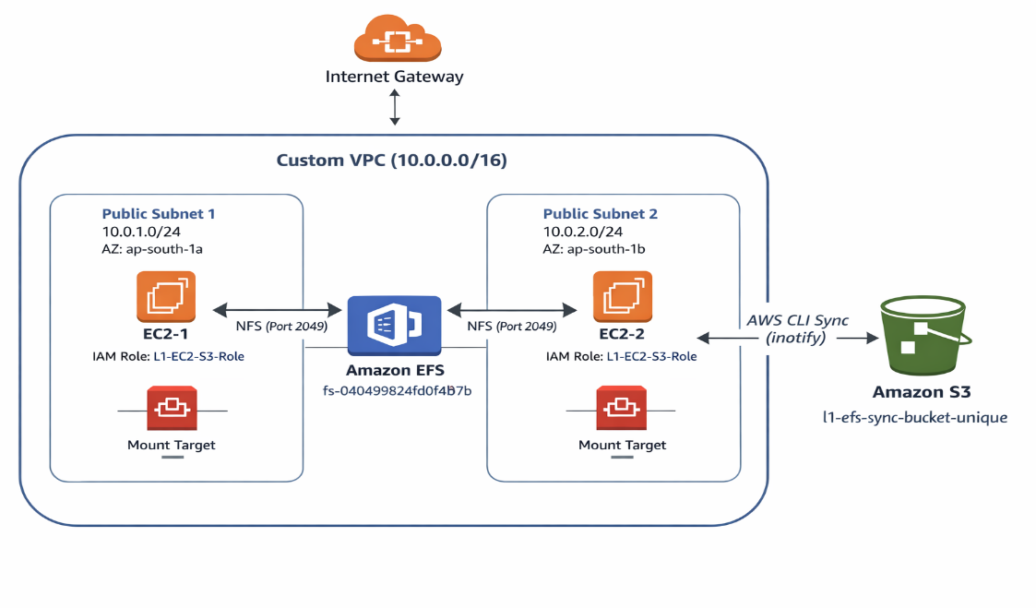

Implementation Details:
- VPC Creation:
- Created custom VPC with CIDR 10.0.0.0/16
- Created two public subnets
- Attached Internet Gateway
- Configured route table
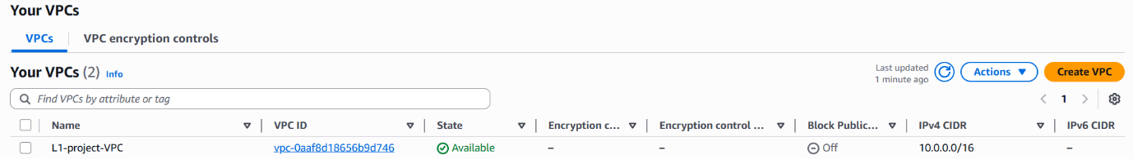
Screenshot:1

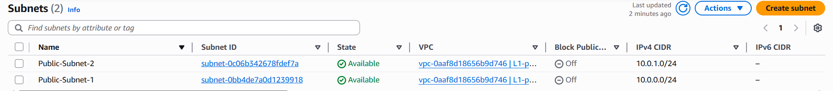
Screenshot:2

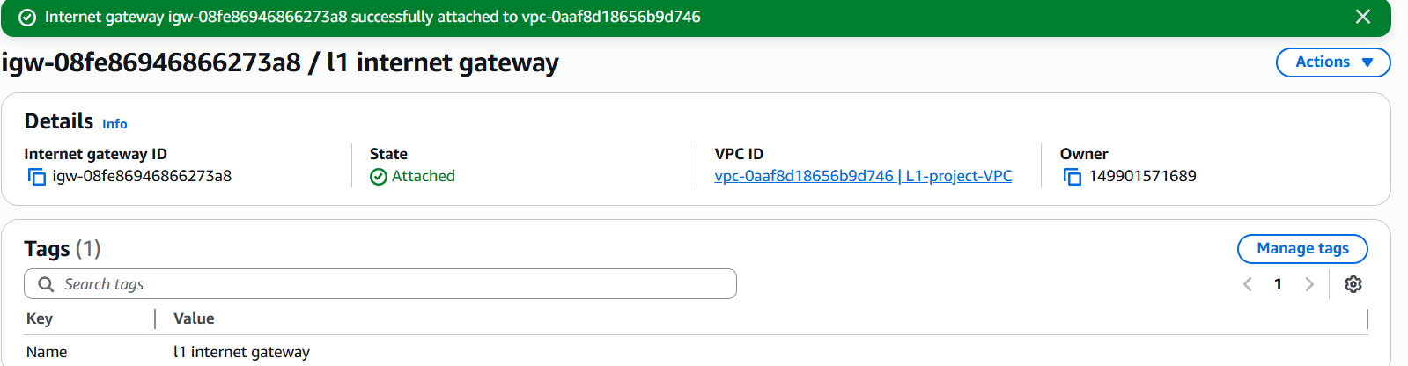
Screenshot:3

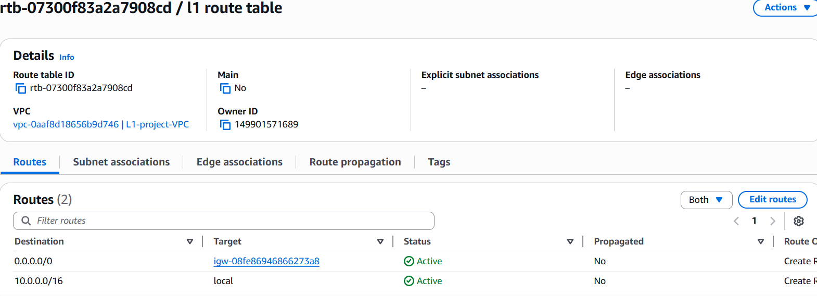
Screenshot:4
- EC2 Deployment:
- Created two instances with two different availability zone
- Attached IAM role
- Verified connectivity
Screenshot:1
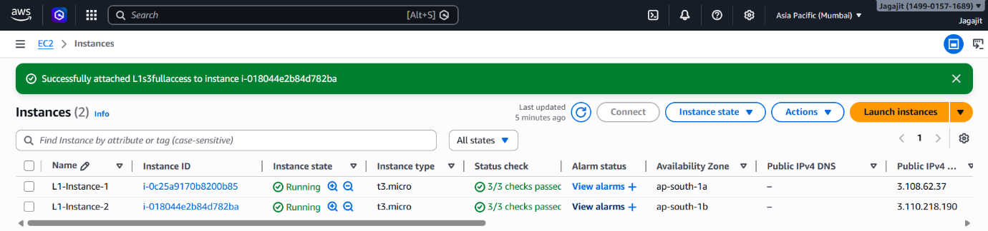

Screenshot:2
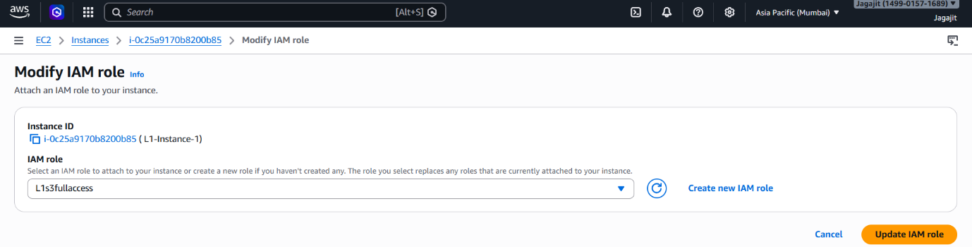
- EFS Configuration:
- Created EFS file system
- Created mount targets in both subnets
- Mounted EFS to /share/projects
- Verified using df -h

Screenshot:1
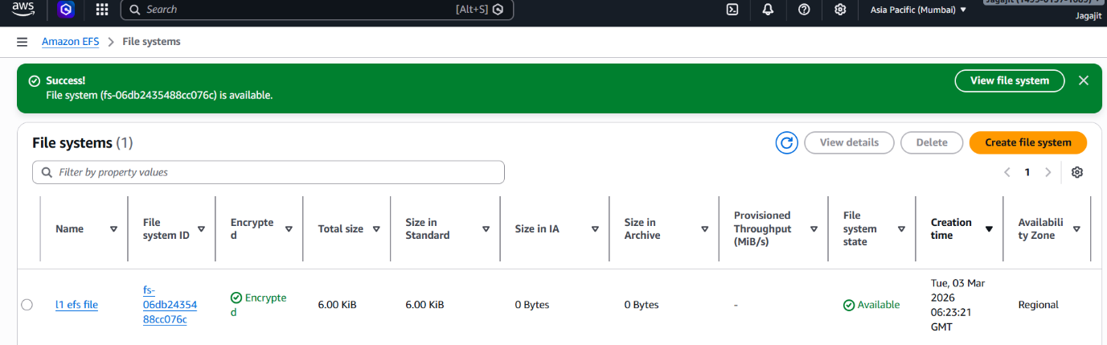

Screenshot:2
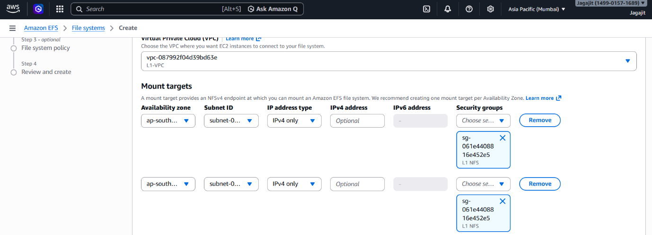
Screenshot:3
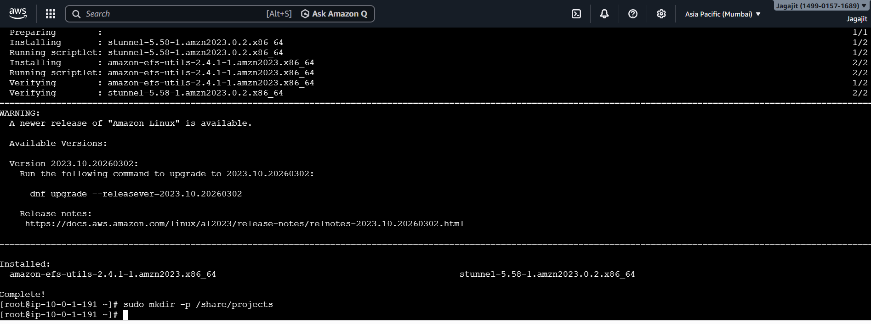
Screenshot:4
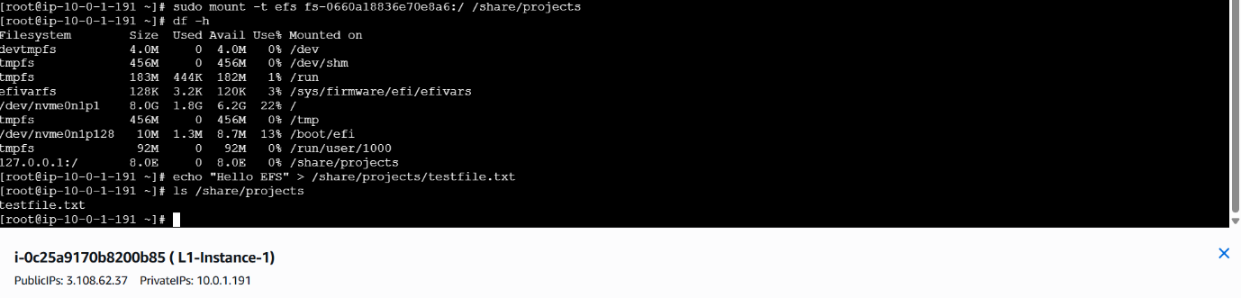

- S3 Bucket Setup:
- Created bucket with public access blocked
- Verified permissions tab
Screenshot:1
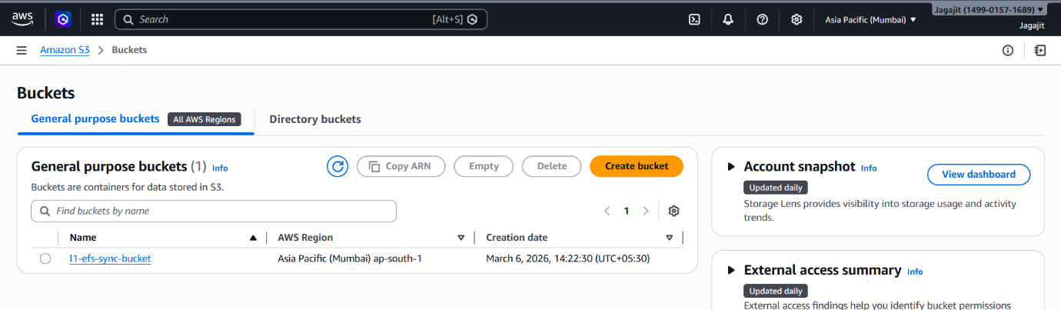

- IAM Role Configuration
- Created least-privilege policy
- Allowed Put Object, Delete Object, List Bucket
- Attached role to EC2
Screenshot:1
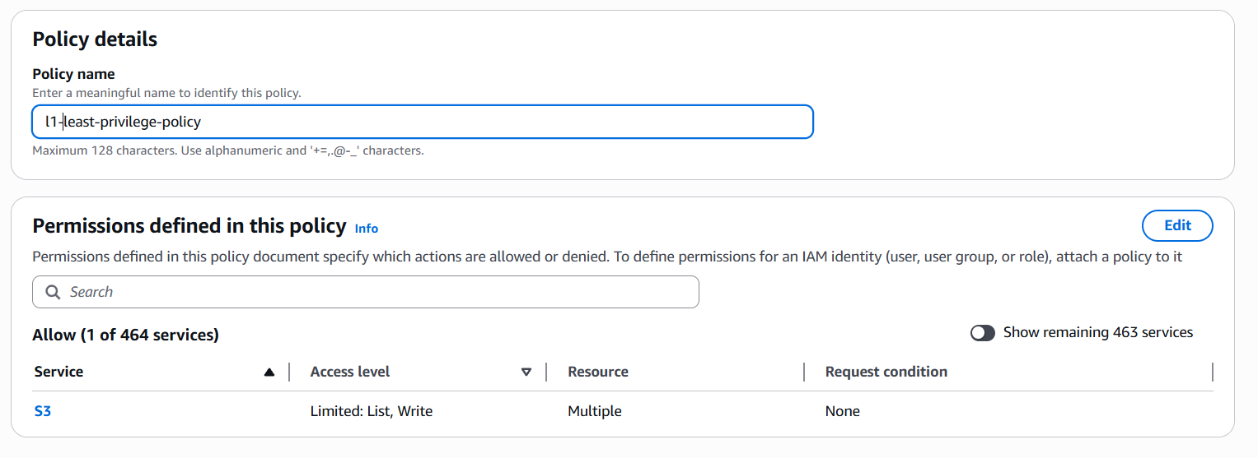

- Real-Time Sync Implementation
- Installed Inotify-tools
- Created efs_sync.sh script
- Configured system service
- Enabled auto-start

Screenshot:1
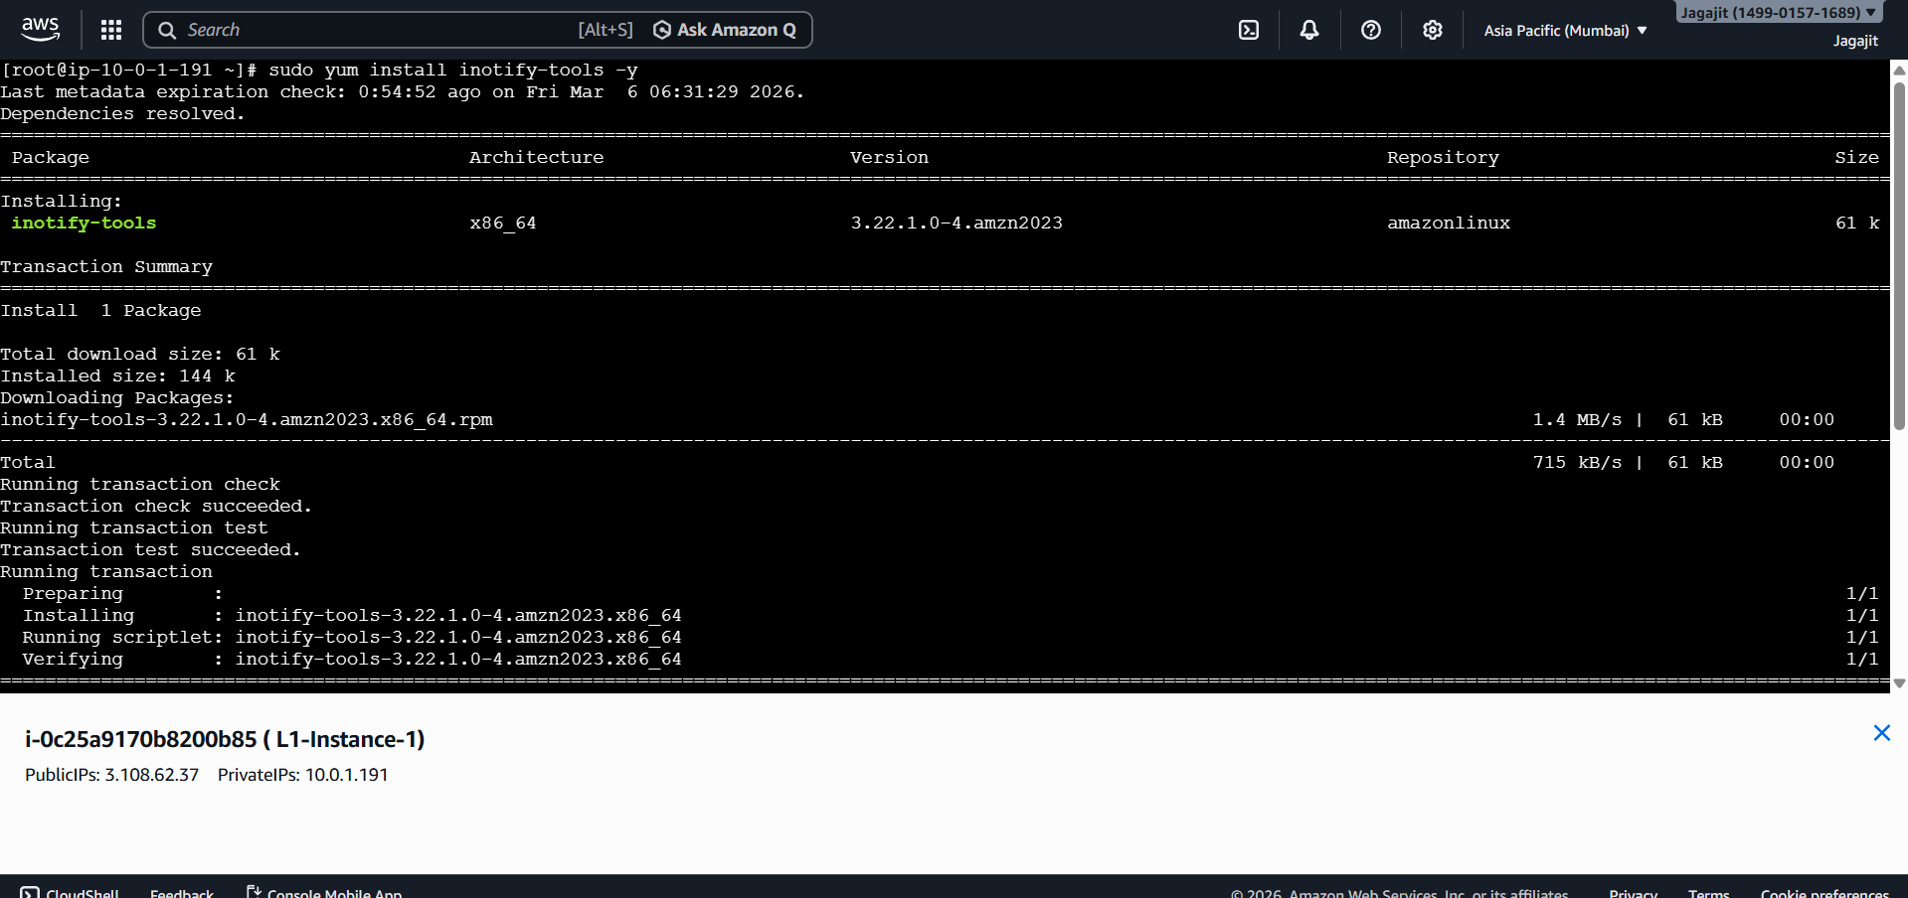
Screenshot:2
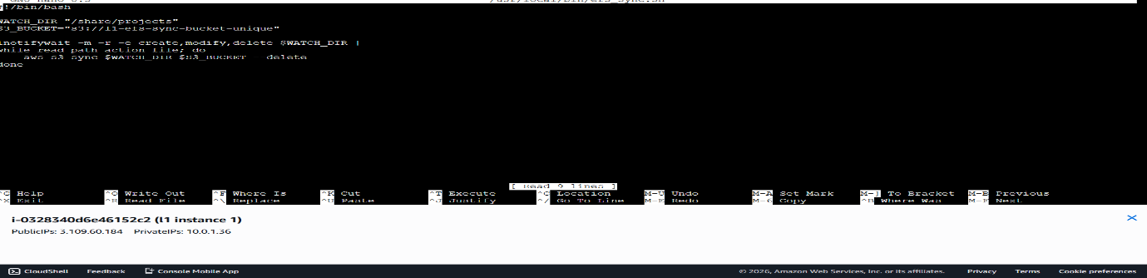
Screenshot:3
Screenshot:4
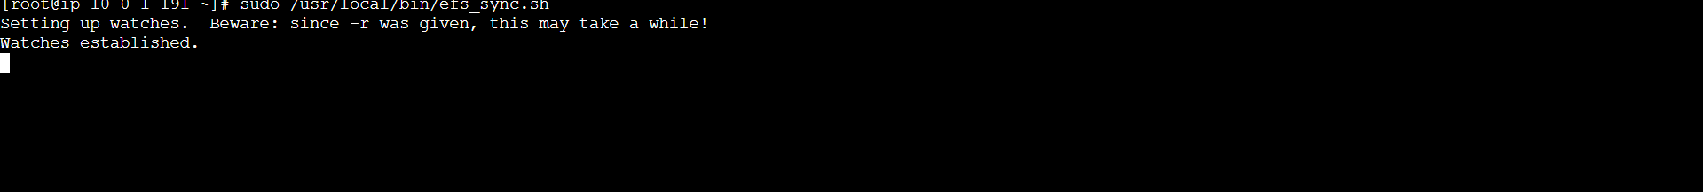

- Testing & Validation:
- Created file in EC2-1
- Verified visibility in EC2-2
- Verified file uploaded to S3
- Tested delete synchronizatio

Screenshot:1
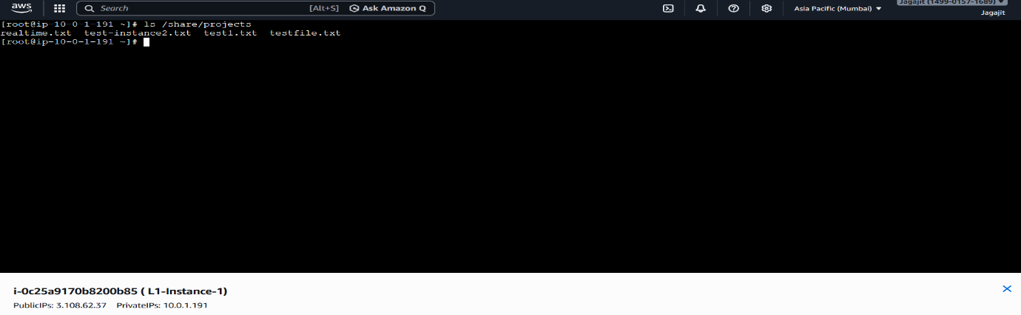Screenshot:2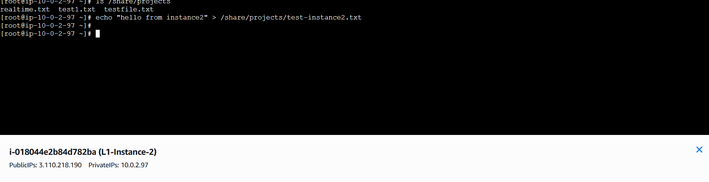Screenshot:3
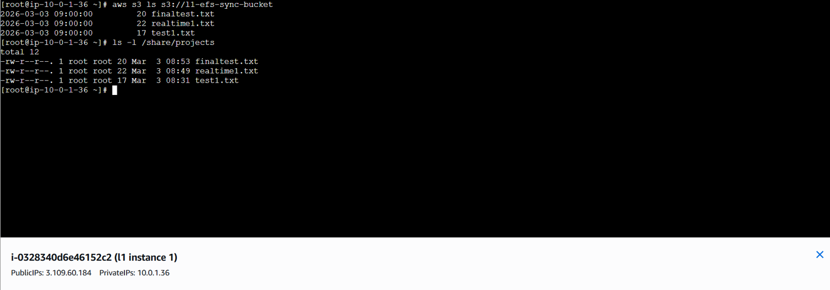
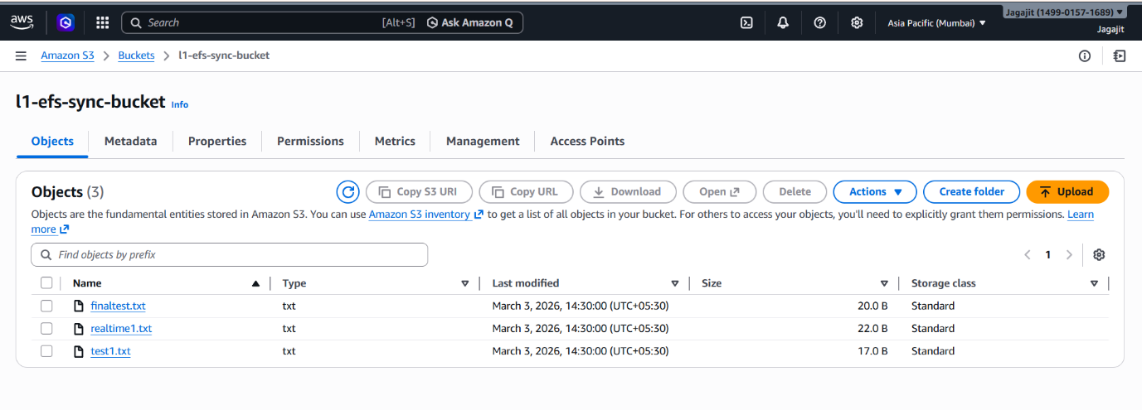
Screenshot:4

Challenges Faced:
The EC2 instance initially failed to mount the EFS file system due to security group restrictions. The EFS mount target requires NFS port 2049 to be open between the EC2 instance and the EFS security group. After allowing inbound NFS (2049) traffic from the EC2 security group, the file system was successfully mounted.
During the project implementation, a synchronization issue occurred where files created in the Amazon EFS directory were not appearing in the Amazon S3 bucket. This was caused by the inotify monitoring script not running properly. After verifying the script configuration and restarting the monitoring process, the issue was resolved and files were successfully synchronized to the S3 bucket in near real-time.

Lessons Learned:
One of the major lessons learned was understanding how critical security group rules are for service communication in AWS. The EC2 instance was initially unable to mount the EFS file system because the NFS port 2049 was not allowed between the EC2 and EFS security groups. After updating the inbound rule to allow NFS traffic, the connection worked successfully. This highlighted the importance of correctly configuring network access between AWS resources.
While implementing the file synchronization from EFS to S3, synchronization issues occurred due to configuration mistakes in scripts and missing permissions. Debugging logs and verifying IAM permissions helped resolve the issue. This emphasized the importance of monitoring logs and validating permissions during automation tasks.
Throughout the project, documenting errors and solutions helped track progress and made troubleshooting easier. This practice improved understanding of AWS services and strengthened problem-solving skills.

Conclusion:
This project successfully demonstrated how to synchronize files from EFS to S3 in near real-time using AWS services. During the project, services like EC2, EFS, S3, IAM, and VPC were configured and integrated to build the architecture.
Several challenges were faced such as EFS mounting issues, security group configuration, subnet problems, and synchronization errors. These issues were resolved through troubleshooting and proper configuration.

